г. Петрозаводск, пр.Ленина 10 - 3
тел./факс +7 (814-2) 76-50-37,
тел./факс +7 (814-2) 76-18-70,
E-mail : anton@sampo90.ru, Afremoff@gmail.com

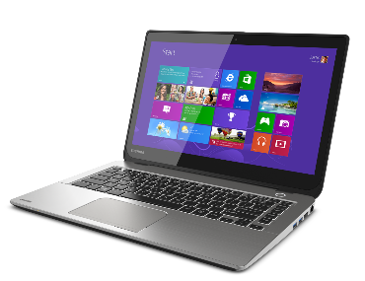
СЕГОДНЯ НА СКЛАДЕ
Ноутбуки
Арт. | Характеристика | Цена
 | HP EliteBook 840 G3/G4 Core i5-6200U 2.3GHz,14" IPS FHD (1920x1080) AG, 8Gb DDR4(1), 256Gb SSD, Silver, Win8Pro(DEMO) | 44/48000
 | DELL Latitude E6530 CORE i7-3720QM 2600Mzh 15” FHD, 8GB DDR4, 500GB HDD,NVS 5200M, Win10Pro ( DEMO) | 46000
 | Lenovo V17-IIL 17.3" FHD (1920x1080) IPS AG, I3-1005G1 1.2G, 2x4GB DDR4 2667, 256GB SSD M.2, Intel UHD, WiFi, BT, NoODD, 2cell 42Wh, NoOS, 1Y CI, 2.2kg | 59 500
 | Ноутбук HP EliteBook 855 G8 AMD Ryzen 7 Pro 5850U 1.9GHz,15.6" FHD (1920x1080) IPS 400cd IR ALS LP AG,8Gb DDR4-3200MHz(1),256Gb SSD NVMe,Al Chassis,56Wh,FPS,Kbd Backlit,Numpad,1.7kg,3yw,Win10Pro | 89 900

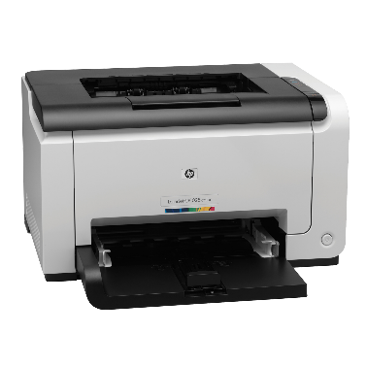

Принтеры и МФУ

4ZB78A#B19 | Принтер HP Laser 107w (A4,1200dpi,20ppm,64Mb,Duplex,USB 2.0/Wi-Fi,AirPrint,HP Smart,1tray 150, 1y warr, cartridge 500 pages in box, repl.SS272C) | 7500
 | HP LaserJet 2420dn 28 стр/мин (ч/б A4) LPT, Ethernet (RJ-45), USB, REF ( 2 картриджа в комплекте по 9000 ) | 15 000
4RY26A#B19 | HP Neverstop Laser 1200n MFP (1200w (p/c/s, A4,600dpi, 20ppm, 64Mb ,LAN/USB 2.0/AirPrint/HP Smart,1 tray 150,toner 5000 page full in box), toner 5000 page full in box ) | 22500
W1A56A#B19 | Принтер HP LaserJet Pro M404dw (A4,1200dpi, 38 ppm, 256 Mb, 2tray 100+250,Duplex, USB2.0/GigEth/WiFi, PS3, ePrint, AirPrint, 1y warr, cartridge 3000 in box, repl. C5F95A) | 24000
CP3525X(ref) | HP COLOR LaserJet CP3525x <CC471A> (A4, 30стр/мин, 512Mb, LCD, USB2.0, сетевой, двусторонняя печать, три лотка) | 15000

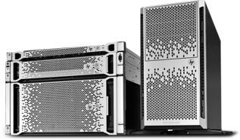
Серверы и СХД
 | HPE Proliant ML350 Gen9 2xE5-2667v4 x2 Processor Kit / 4x8GB PC4-2400 RAM/8xSFF / P440ar 2Gb +fbwc, 2x800w psu, iLo4 Adv, Bezel, pads | 220000

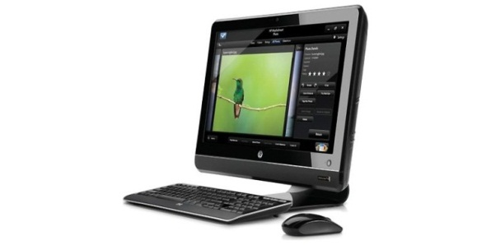
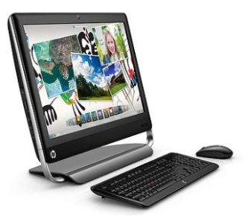
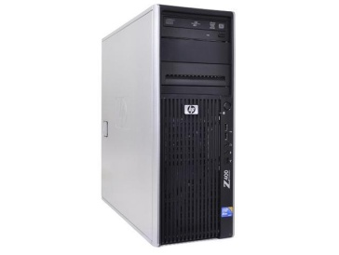

г. Петрозаводск, пр.Ленина 10 -3
тел./факс +7 (814-2) 76-50-37,
тел./факс +7 (814-2) 76-18-70,
E-mail : sales@sampo90.ru

ПК и Моноблоки

 | ПК DELL Optiplex 7010 Core-i5 -3470, 3200Mzh,8 GB, 250GB,SFF, Win7Pro (DEMO) | 18 000
L1X62AV | ПК EliteDesk 705 G1/G2 AMD Pro A8 8600B 3100Mzh, 8GB,500 HDD 2.5”,mini.Win10Pro ( DEMO) | 20 000
36T46ES#ACB | ПК HP 290 G4 MT Pentium 6400,4GB,128GB SSD,No ODD,USB kbd&mouse,Realtek RTL8821CE AC 1x1 BT 4.2 WW,Win10Pro(64-bit)Entry,1-1-1 | 34500
3080-2729 | ПК Dell Optiplex 3080 MT Core i3-10105 (3,7GHz) 8GB (1x8GB) DDR4 256GB SSD Intel UHD 630 TPM Linux 1y NBD | 38 500
3888-2963 | Dell Vostro 3888 MT Core i7-10700F (2,9GHz) 8GB (1x8GB) DDR4 512GB SSD NVidia GT 730 (2GB) MCR W10 Pro 1 year NBD | 79 000
459H6EA#ACB | Dell Inspiron AIO 5400 23,8" FullHD IPS AG Non-Touch, Core i3-1115G4, 8Gb, 256GB SSD, Intel HD 620 , 1YW, Win10Home, Silver Arch stand, Wi-Fi/BT, KB&Mouse | 71000

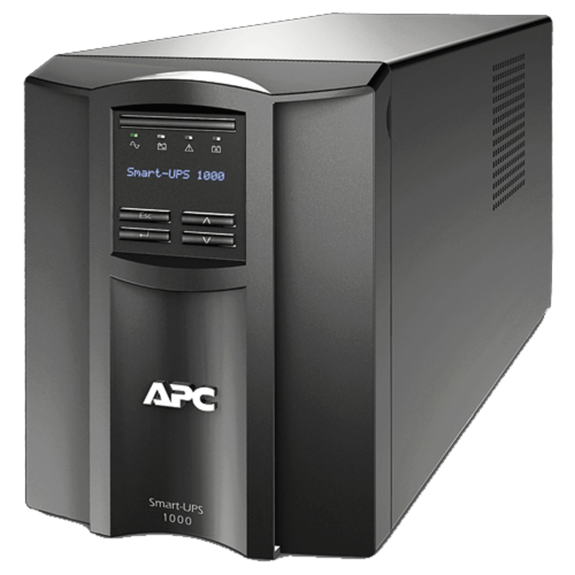

ИБП и стабилизаторы

ISBR800E | IRBIS UPS Personal plus 800VA/480W, AVR, 6xSchuko outlets(6 w battery support), 1 year warranty | 4990
RPT-1500AP | Powercom Raptor, Line-Interactive, 1500VA/900W, Tower, 6xIEC, USB (295842) | 9999
LI32111CT00 | Источник бесперебойного питания LIEBERT itON 600VA/360W, 230V, 2xSchuko Outlet | 2999
SRV10KIL | APC Easy UPS SRV 10000VA 230V with External Battery Pack | 299000

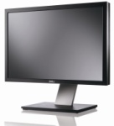

Мониторы

2720-0711 | Dell 27" SE2720H 27" LCD S/BK (IPS; 16:9; 300 cd/m2; 1000:1; 5ms; 1920x1080; 178/178; VGA; DP; Tilt ) | 17000
2422-5052 | Dell 23,8" SE2422H LCD BK/BK ( VA; 16:9; 250 cd/m2; 3000:1; 5ms; 1920x1080x75Hz; 178/178; VGA; HDMI, Tilt; VESA) | 15000
2721-9497 | Dell 27" S2721HSX LCD bk/BK ( IPS; 16:9; 300 cd/m2; 1000:1; 4ms; 1920x1080x75Гц; 178/178; DP; HDMI; HAS; Swiv; Pivot) | 18000

21.12.2021

