г. Петрозаводск, пр. Ленина 10 - 3
тел./факс +7 (814-2) 76-50-37,
тел./факс +7 (814-2) 76-18-70,
E-mail : anton@sampo90.ru, Afremoff@gmail.com

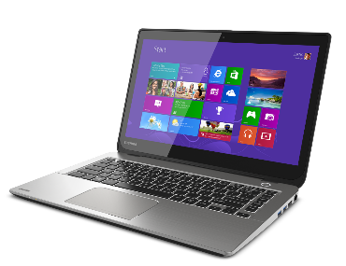
СЕГОДНЯ НА СКЛАДЕ
Ноутбуки
Арт. | Характеристика | Цена
 | LENOVO T440s 14" FHD (1600x900) Core i5-4200U 1.9GHz, 14" FHD AG, 8Gb DDR4(1), 128Gb SSD, 1.8kg, 1y, Win8Pro (demo) | 29500
 | HP EliteBook 820 G3 Core i5-6200U 2.3GHz,12.5" IPS FHD (1920x1080) AG, 8Gb DDR4(1), 256Gb SSD, Silver, Win10Pro(DEMO) | 44000
 | HP EliteBook 840 G3 Core i5-6200U 2.3GHz,14" FHD (1920x1080) AG, 8Gb DDR4(1), 256Gb SSD, Silver, Win10Pro(DEMO) | 45000
 | ASUS ZenBook 15.4" IPS FHD Core i7-4720HQ , 16Gb DDR4(1), 512Gb SSD,GeForce 960M, 1y, Win10Pro (NEW in Box) | 62 000

Установка в любой ноутбук DEMO накопителя 120Gb/240Gb SSD увеличивает стоимость на 2500/4000 рублей соответственно.

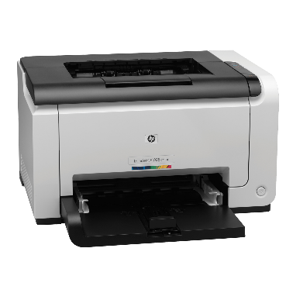

Принтеры и МФУ

4ZB78A#B19 | Принтер HP Laser 107w (A4,1200dpi,20ppm,64Mb,Duplex,USB 2.0/Wi-Fi,AirPrint,HP Smart,1tray 150, 1y warr, cartridge 500 pages in box, repl.SS272C) | 7500
W1A56A | Принтер HP LaserJet Pro M404dw (A4,1200dpi, 38 ppm, 256 Mb, 2tray 100+250,Duplex, USB2.0/GigEth/ WiFi, PS3, ePrint, AirPrint, 1y warr, cartridge 3000 in box, repl. C5F95A) | 26000
W1A31A | HP LaserJet Pro MFP M428dw RU (p/c/s, A4, 38 ppm, 512Mb, Duplex, 2 trays 100+250, ADF 50, USB 2.0/GigEth/Dual-band WiFi with Bluetooth Low Energy ,Cartridge 10 000 pages in box, 1y warr., repl. F6W16A) | 29900
СС494A (ref ) | HP COLOR LaserJet CP4525 <CC494A> (A4, 40стр/мин, 512Mb, LCD, USB2.0, сетевой, двусторонняя печать, два лотка) | 25 000
1TJ09A | Многофункциональное устройство HP Smart Tank 500 Wireless All-In-One (p/c/s, A4, 4800x1200dpi, CISS, 11(5)ppm, 1tray 100, USB2.0/ , 1y war, cartr. B 18K & 8K CMY in box) | 13500
4RY26A#B19 | HP Neverstop Laser 1200w MFP (1200w (p/c/s, A4,600dpi, 20ppm, 64Mb ,Wi-Fi/USB 2.0/AirPrint/HP Smart,1 tray 150,toner 5000 page full in box), toner 5000 page full in box ) | 22500
CP3525X(ref) | HP COLOR LaserJet CP3525x <CC471A> (A4, 30стр/мин, 512Mb, LCD, USB2.0, сетевой, двусторонняя печать, три лотка) | 20 000

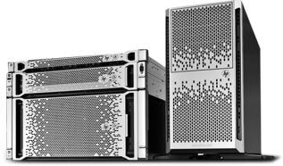
Серверы и СХД
7Y48S04B00 | Сервер в сборе Lenovo ThinkSystem ST50 Tower 4U, 1xIntel Core i3-8100 4C+2 (65W/3.6GHz), 1x16GB/2666MHz/2Rx8/1.2V UDIMM, 2x1TB 3,5" HDD, SW RAID, noDVD, 1x2.8m Line Cord, 1GbE, 1x | 44900

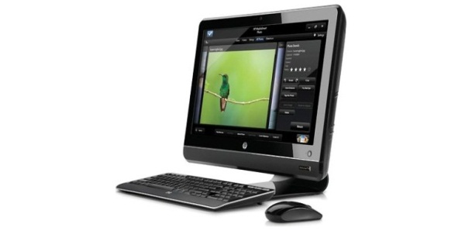
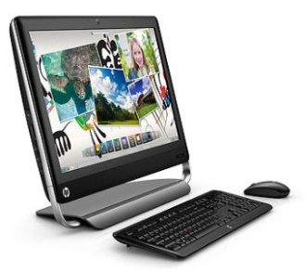
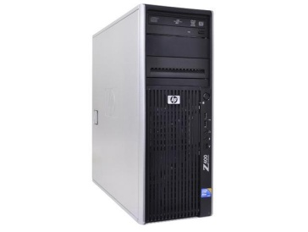

г. Петрозаводск, пр.Ленина 10 -3
тел./факс +7 (814-2) 76-50-37,
тел./факс +7 (814-2) 76-18-70,
E-mail : sales@sampo90.ru

ПК и Моноблоки

3681-2567 | Персональный компьютер Dell Vostro 3681 SFF Core i3-10100 (3,6GHz) 4GB (1x4GB) DDR4 256GB SSD Intel UHD 630 MCR Linux 1 year NBD | 33900
4YV73EA#ACB | HP Bundle 260 G3 Mini Core i3-7130U,4GB,500GB,USBkbd/mouse,Realtek RTL8821CE AC 1x1 BT,Monitor Quick Release,Win10Pro(64-bit),1-1-1Wty +Monitor V214.7in | 41000
1Q7Q3ES#ACB | HP Bundle ProDesk 400 G6 MT Core i3-9100,8GB,256GB SSD,USB kbd&mouse,Intel 9560 AC 2x2 BT,DP Port,FreeDOS,1-1-1 Wty +HP Monitor N246v 23.8in | 51 000
 | Dell Optiplex 9020 CORE i5, 8Gb, 500Gb, DVDRW, INTEL, SFF, Win8 ( Ref ) Demo | 19 500

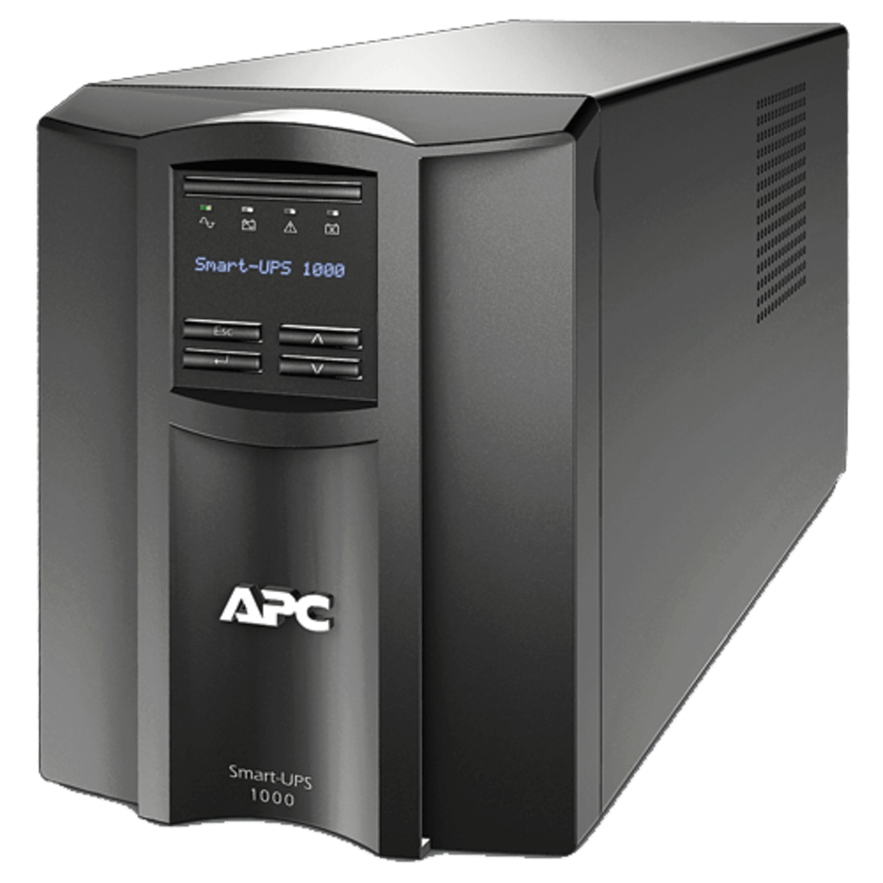
ИБП и стабилизаторы

SPD-1000U | ИБП Powercom Back-UPS SPIDER, Line-Interactive, 1000VA/550W, Tower, Schuko, USB (688277) | 7 500
RPT-1500AP-LCD | Powercom Raptor, Line-Interactive, 1500VA/900W, Tower, 4xSchuko, LCD, USB (1107535)) | 12 500
RPT-1000AP-LCD | Powercom Raptor, OffLine, 1025VA/615W, Tower, 6xSchuko, LCD, USB | 10500
ISBR800E | IRBIS UPS Personal plus 800VA/480W, AVR, 6xSchuko outlets(6 w battery support), 1 year warranty | 4990
TCA-1200 | Стабилизаторы напряжения электрического тока Powercom Voltage Regulator, 1200VA, White, Schuko (95255) | 2000
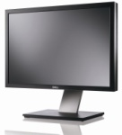

Мониторы

2720-0711 | Dell 27" SE2720H 27" LCD S/BK (IPS; 16:9; 300 cd/m2; 1000:1; 5ms; 1920x1080; 178/178; VGA; DP; Tilt ) | 15000
LS24D300HSI/RU | Samsung 24" S24D300H TN LED 16:9 1920x1080 2ms 250cd 1000:1 170/160 D-Sub HDMI External Power Supply Glossy Black | 9900
2419-0193 | Dell 23,8" E2419HR LCD BK/BK ( IPS; 16:9; 250cd/m2; 1000:1; 5ms; 1920x1080; 178/178; VGA, HDMI; Tilt; ) | 9900
EW2775ZH | BENQ 27" EW2775ZH AMVA+ LED, 16:9, 1920x1080, 12ms(4) 300cd/m2, 20M:1, 178/178, D-Sub, 2*HDMI, Speaker Black | 13500

15.02.2020

