г. Петрозаводск, пр.Ленина 10 - 3
тел./факс +7 (814-2) 76-50-37,
тел./факс +7 (814-2) 76-18-70,
E-mail : anton@sampo90.ru, Afremoff@gmail.com

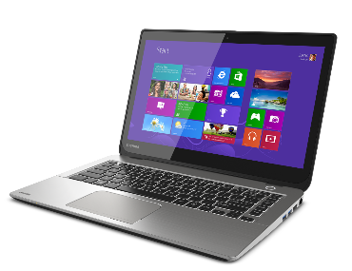
СЕГОДНЯ НА СКЛАДЕ
Ноутбуки
Арт. | Характеристика | Цена
2D288EA#ACB | Ноутбук без сумки HP ProBook 440 G7 Core i3-10110U 2.1GHz,14 FHD (1920x1080) AG 4Gb DDR4(1),128GB SSD,45Wh LL,FPR,1.6kg,1y,Silver,Dos | 52000
 | LENOVO T440s 14" FHD (1600x900) Core i5-4200U 1.9GHz, 14" FHD AG, 8Gb DDR4(1), 128Gb SSD, 1.8kg, 1y, Win8Pro (demo) | 29500
20SM003HRU | Lenovo ThinkBook 15-IIL 15.6" FHD (1920x1080) IPS AG 250N, I5-1035G1 1.1G, 4GB DDR4 2666, 1TB/7200rpm, Intel UHD, NoWWAN, WiFi 6, BT, FPR, TPM, 3Cell 45Wh, No OS, 1YR C.I, Mineral Grey, 1,7 kg | 54500
1Q5T9ES#ACB | HP ProBook 650 G5 Core i3-8145U 2.1GHz,15.6" FHD (1920x1080) IPS AG,8Gb DDR4-2400(1),256Gb SSD,DVDRW,COM-port,FPS,2.2kg,1y,Silver,FreeDOS | 65500
 | HP EliteBook 840 G3 Core i5-6200U 2.3GHz,14" FHD (1920x1080) AG, 8Gb DDR4(1), 256Gb SSD, Silver, Win10Pro(DEMO) | 45 000

Установка в любой ноутбук DEMO накопителя 120Gb/240Gb SSD увеличивает стоимость на 2500/4000 рублей соответственно.

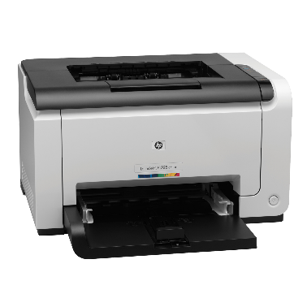

Принтеры и МФУ

4ZB78A#B19 | Принтер HP Laser 107w (A4,1200dpi,20ppm,64Mb,Duplex,USB 2.0/Wi-Fi,AirPrint,HP Smart,1tray 150, 1y warr, cartridge 500 pages in box, repl.SS272C) | 7500
W1A56A | Принтер HP LaserJet Pro M404dw (A4,1200dpi, 38 ppm, 256 Mb, 2tray 100+250,Duplex, USB2.0/GigEth/ WiFi, PS3, ePrint, AirPrint, 1y warr, cartridge 3000 in box, repl. C5F95A) | 26000
W1A31A | HP LaserJet Pro MFP M428dw RU (p/c/s, A4, 38 ppm, 512Mb, Duplex, 2 trays 100+250, ADF 50, USB 2.0/GigEth/Dual-band WiFi with Bluetooth Low Energy ,Cartridge 10 000 pages in box, 1y warr., repl. F6W16A) | 29900
4SR29A | HP Ink Tank 315 AiO Printer (p/c/s, A4, 4800x1200dpi, CISS, 11(5)ppm, 1tray 100, USB2.0, 1y war, cartr. B | 10000
4ZB83A#B19 | МФУ HP Laser MFP 135dw (A4, 1200dpi, 28ppm, 256MB, 1 tray 150, duplex, USB2.0, WiFi, ePrint, AirPrint, Cartridge 500 pages in box, 1 warr) | 12000
1TJ09A | Многофункциональное устройство HP Smart Tank 515 Wireless All-In-One (p/c/s, A4, 4800x1200dpi, CISS, 11(5)ppm, 1tray 100, USB2.0/ Wi-Fi, 1y war, cartr. B 18K & 8K CMY in box) | 15500
4RY23A#B19 | HP Neverstop Laser 1000w Printer (A4, 600dpi, 20ppm, 32Mb, Wi-Fi/USB 2.0/AirPrint/HP Smart , 1 tray 150, toner 5000 page full in box ) | 15500

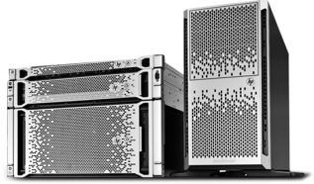
Серверы и СХД
7Y48S04B00 | Сервер в сборе Lenovo ThinkSystem ST50 Tower 4U, 1xIntel Core i3-8100 4C+2 (65W/3.6GHz), 1x16GB/2666MHz/2Rx8/1.2V UDIMM, 2x1TB 3,5" HDD, SW RAID, noDVD, 1x2.8m Line Cord, 1GbE, 1x | 37900

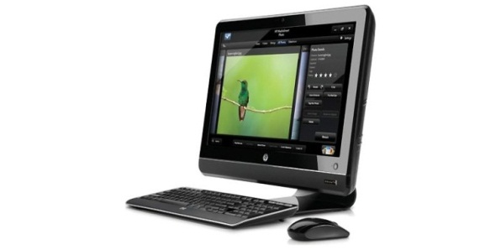
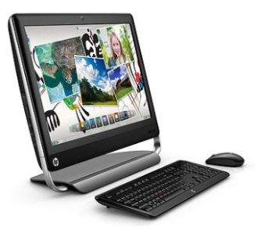
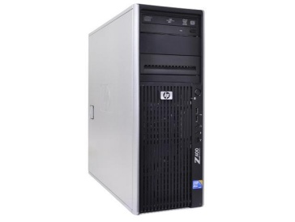

г. Петрозаводск, пр.Ленина 10 -3
тел./факс +7 (814-2) 76-50-37,
тел./факс +7 (814-2) 76-18-70,
E-mail : sales@sampo90.ru

ПК и Моноблоки

14R02EA#ACB | ПК HP S01-pF0008ur MT,Intel Core i5- 9400 6C, 8GB (1x8GB) 2400 DDR4,SSD 256Gb, Intel Internal Graphics, noDVD, no kbd & no mouse, Jet Black, DOS, 1Y Wty | 41500
3681-2567 | Персональный компьютер Dell Vostro 3681 SFF Core i3-10100 (3,6GHz) 4GB (1x4GB) DDR4 256GB SSD Intel UHD 630 MCR Linux 1 year NBD | 33900
4YV73EA#ACB | HP Bundle 260 G3 Mini Core i3-7130U,4GB,500GB,USBkbd/mouse,Realtek RTL8821CE AC 1x1 BT,Monitor Quick Release,Win10Pro(64-bit),1-1-1Wty +Monitor V214.7in | 41000
1Q7Q3ES#ACB | HP Bundle ProDesk 400 G6 MT Core i3-9100,8GB,256GB SSD,USB kbd&mouse,Intel 9560 AC 2x2 BT,DP Port,FreeDOS,1-1-1 Wty +HP Monitor N246v 23.8in | 51 000

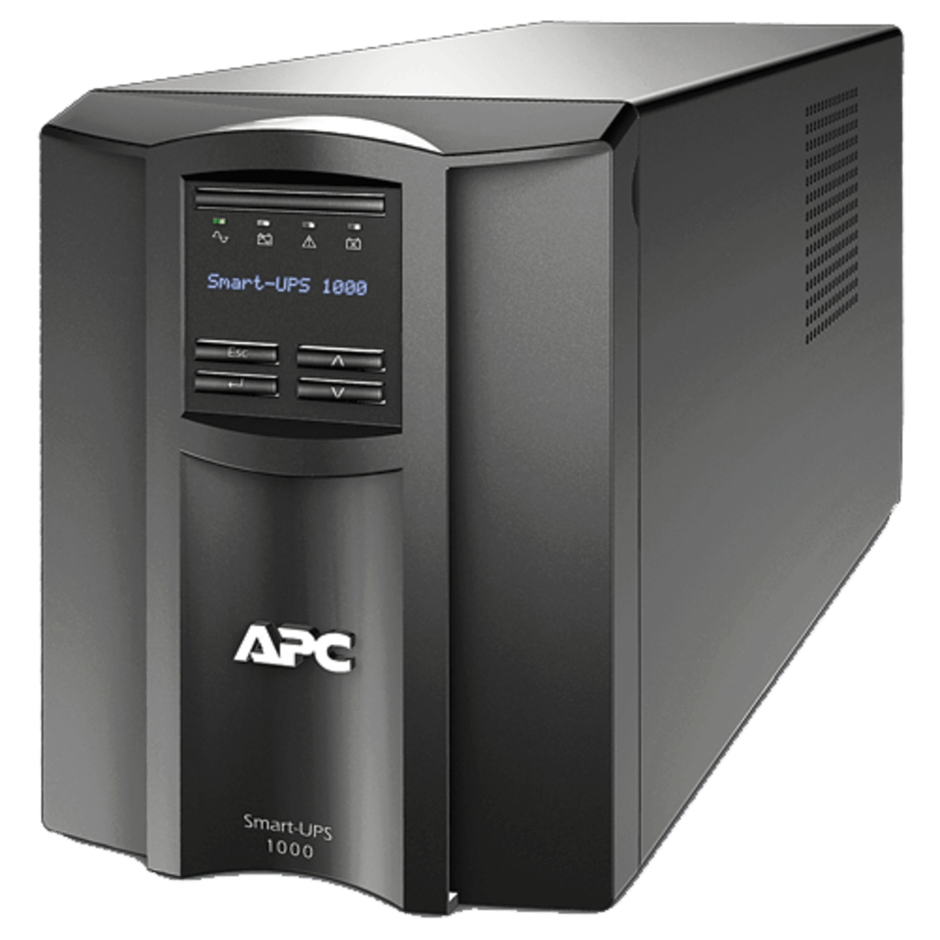

ИБП и стабилизаторы

ISN1500ET | IRBIS UPS Personal plus 600VA/380W, AVR, 2xSchuko outlets battery support), 2 year warranty | 3990
RPT-1500AP-LCD | Powercom Raptor, Line-Interactive, 1500VA/900W, Tower, 4xSchuko, LCD, USB (1107535)) | 12 500
RPT-1000AP-LCD | Powercom Raptor, OffLine, 1025VA/615W, Tower, 6xSchuko, LCD, USB | 10500
ISBR800E | IRBIS UPS Personal plus 800VA/480W, AVR, 6xSchuko outlets(6 w battery support), 1 year warranty | 4990
TCA-1200 | Стабилизаторы напряжения электрического тока Powercom Voltage Regulator, 1200VA, White, Schuko (95255) | 2000
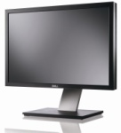

Мониторы

2720-0711 | Dell 27" SE2720H 27" LCD S/BK (IPS; 16:9; 300 cd/m2; 1000:1; 5ms; 1920x1080; 178/178; VGA; DP; Tilt ) | 15000
LS24D300HSI/RU | Samsung 24" S24D300H TN LED 16:9 1920x1080 2ms 250cd 1000:1 170/160 D-Sub HDMI External Power Supply Glossy Black | 9900
2420-0704 | Dell 23,8" E2420HS LCD BK/BK ( IPS; 16:9; 250cd/m2; 1000:1; 5ms; 1920x1080; 178/178; VGA, HDMI; Tilt; HAS; Spk 2х1W) | 11500

03.12.2020

