г. Петрозаводск, пр.Ленина 10 - 3
тел./факс +7 (814-2) 76-50-37,
тел./факс +7 (814-2) 76-18-70,
E-mail : anton@sampo90.ru, Afremoff@gmail.com

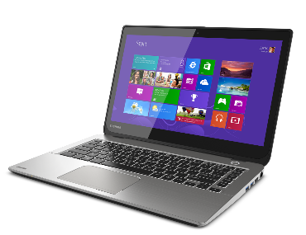
СЕГОДНЯ НА СКЛАДЕ
Ноутбуки
Арт. | Характеристика | Цена
 | LENOVO T440 14" FHD (1600x900) Core i5-4200U 1.9GHz, 14" FHD AG, 4Gb DDR4(1), 128Gb SSD, 1.8kg, 1y, Win10Pro (demo) | 24000
 | LENOVO T430s 14" FHD (1600x900) Core i5-3320U 1.9GHz, 14" FHD AG, 4Gb DDR4(1), 320GB, 1.8kg, 1y, Win10Pro(demo) | 22000

Установка в любой ноутбук DEMO накопителя 120Gb/240Gb SSD увеличивает стоимость на 2500/4000 рублей соответственно.

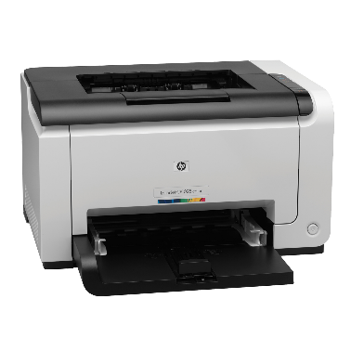

Принтеры и МФУ
4ZB78A#B19 | Принтер HP Laser 107w (A4,1200dpi,20ppm,64Mb,Duplex,USB 2.0/Wi-Fi,AirPrint,HP Smart,1tray 150, 1y warr, cartridge 500 pages in box, repl.SS272C) | 7500
W1A56A | Принтер HP LaserJet Pro M404dw (A4,1200dpi, 38 ppm, 256 Mb, 2tray 100+250,Duplex, USB2.0/GigEth/ WiFi, PS3, ePrint, AirPrint, 1y warr, cartridge 3000 in box, repl. C5F95A) | 26000
W1A31A | HP LaserJet Pro MFP M428dw RU (p/c/s, A4, 38 ppm, 512Mb, Duplex, 2 trays 100+250, ADF 50, USB 2.0/GigEth/Dual-band WiFi with Bluetooth Low Energy ,Cartridge 10 000 pages in box, 1y warr., repl. F6W16A) | 29900
4SR29A | HP Ink Tank 315 AiO Printer (p/c/s, A4, 4800x1200dpi, CISS, 11(5)ppm, 1tray 100, USB2.0, 1y war, cartr. B | 10000
4ZB83A#B19 | МФУ HP Laser MFP 135dw (A4, 1200dpi, 28ppm, 256MB, 1 tray 150, duplex, USB2.0, WiFi, ePrint, AirPrint, Cartridge 500 pages in box, 1 warr) | 12000
1TJ09A | Многофункциональное устройство HP Smart Tank 515 Wireless All-In-One (p/c/s, A4, 4800x1200dpi, CISS, 11(5)ppm, 1tray 100, USB2.0/ Wi-Fi, 1y war, cartr. B 18K & 8K CMY in box) | 15500
4RY23A#B19 | HP Neverstop Laser 1000w Printer (A4, 600dpi, 20ppm, 32Mb, Wi-Fi/USB 2.0/AirPrint/HP Smart , 1 tray 150, toner 5000 page full in box ) | 15500

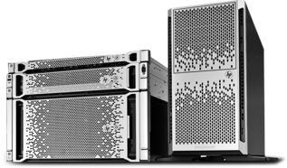
Серверы и СХД
7Y48S04B00 | Сервер в сборе Lenovo ThinkSystem ST50 Tower 4U, 1xIntel Core i3-8100 4C+2 (65W/3.6GHz), 1x16GB/2666MHz/2Rx8/1.2V UDIMM, 2x1TB 3,5" HDD, SW RAID, noDVD, 1x2.8m Line Cord, 1GbE, 1x | 49900

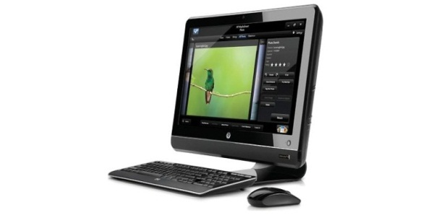
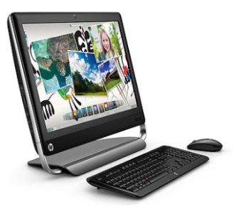
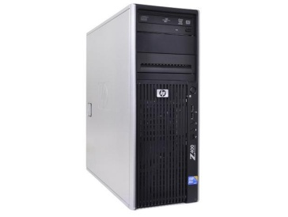

г. Петрозаводск, пр.Ленина 10 -3
тел./факс +7 (814-2) 76-50-37,
тел./факс +7 (814-2) 76-18-70,
E-mail : sales@sampo90.ru

ПК и Моноблоки

14R02EA#ACB | ПК HP S01-pF0008ur MT,Intel Core i5- 9400 6C, 8GB (1x8GB) 2400 DDR4,SSD 256Gb, Intel Internal Graphics, noDVD, no kbd & no mouse, Jet Black, DOS, 1Y Wty | 41500
8NC98ES | HP ProDesk 600 G3 SFF Core i7-7700 (3.6-4.2GHz, 4Cores, vPro), 4Gb DDR4-2400(1), 1TB 7200rpm, WiFi+BT, Usb Business Slim Kbd+USB Mouse, CardReader, Intrusion Sensor, Stand, Platinum 180W, 3/3/3yw, Win10p | 43000
7PF99ES#ACB | HP Bundle ProDesk 405 G4 Mini AthlonPRO200E, 8GB, 1TB, USB kbd/mouse, VGA Port,Quick Release,DOS,1-1-1Wty+ HP Monitor N246v 23.8in | 43000
4ZA85ES#ACB | HP ProDesk 600 G3 SFF Core i3-6100 3.7GHz, 4Gb DDR4-2400(1), 500GB , WiFi+BT, Usb Business Slim Kbd+USB Mouse, VGA, Platinum 180W, 3/3/3yw, Win10pro | 31000

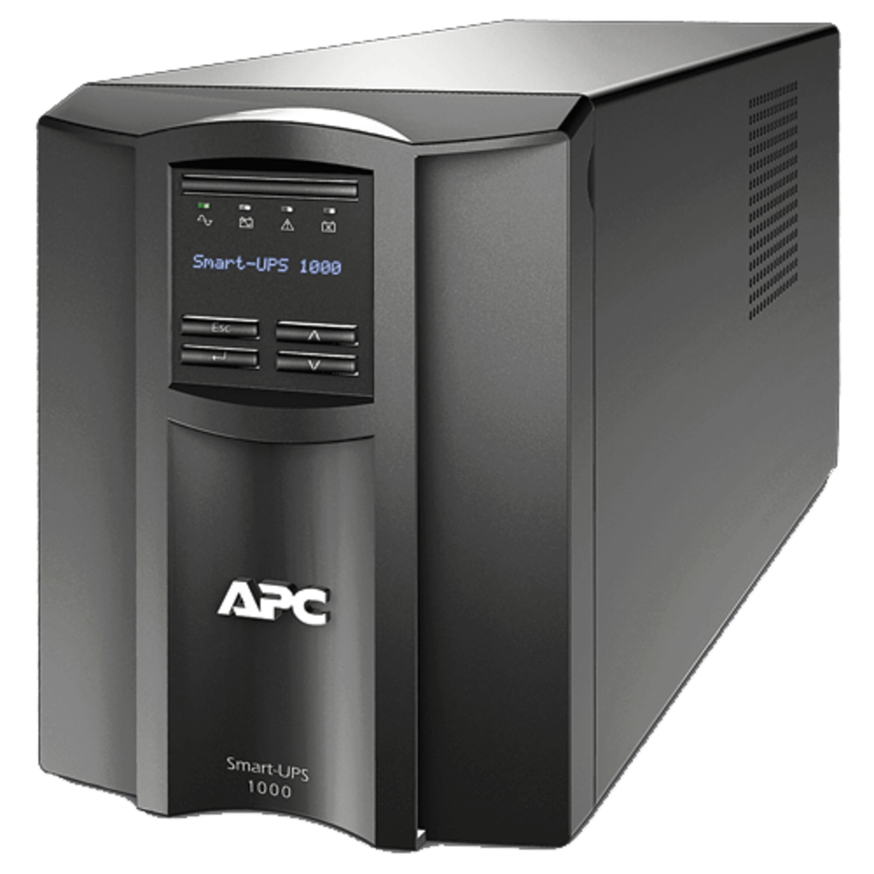
ИБП и стабилизаторы

ISN1500ET | IRBIS UPS Personal plus 600VA/380W, AVR, 2xSchuko outlets battery support), 2 year warranty | 3990
RPT-1500AP-LCD | Powercom Raptor, Line-Interactive, 1500VA/900W, Tower, 4xSchuko, LCD, USB (1107535)) | 12 500
RPT-1000AP-LCD | Powercom Raptor, OffLine, 1025VA/615W, Tower, 6xSchuko, LCD, USB | 10500
ISBR800E | IRBIS UPS Personal plus 800VA/480W, AVR, 6xSchuko outlets(6 w battery support), 1 year warranty | 4990
TCA-1200 | Стабилизаторы напряжения электрического тока Powercom Voltage Regulator, 1200VA, White, Schuko (95255) | 2000
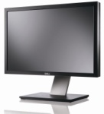
Мониторы

2720-0711 | Dell 27" SE2720H 27" LCD S/BK (IPS; 16:9; 300 cd/m2; 1000:1; 5ms; 1920x1080; 178/178; VGA; DP; Tilt ) | 15000
2318-6882 | Dell 23" E2318H LCD BK/BK ( IPS; 16:9; 250 cd/m2; 1000:1; 5ms; 1920x1080;178/178; VGA, DP; Tilt) | 10500
2216-4466 | Dell 21,5" E2216HV LCD BK/BK (TN; 16:9; 200 cd/m2; 600:1; 5ms;1920x1080; 90/65; VGA; Tilt) | 7900
2420-0704 | Dell 23,8" E2420HS LCD BK/BK ( IPS; 16:9; 250cd/m2; 1000:1; 5ms; 1920x1080; 178/178; VGA, HDMI; Tilt; HAS; Spk 2х1W) | 11500
2720-0711 | Dell 27" SE2720H 27" LCD S/BK (IPS; 16:9; 300 cd/m2; 1000:1; 5ms; 1920x1080; 178/178; VGA; DP; Tilt ) | 15000

27.10.20

